NS009 Switch Controller Upgrade Tool Instructions

After system upgrading of the N-Switch console to version 12.0.0, the NS009 controller needs to be upgraded with the software package before it can be connected normally. The upgrade method is as follows:

- Software Tool Name: N-switch 12.0.0 version controller upgrade package.exe;

- Upgrade Steps:

① Download the software tool to the computer:

② Double clik to run the upgrading software tool.
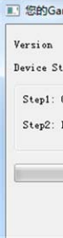
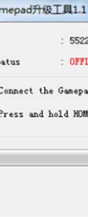
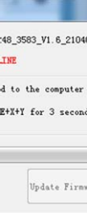
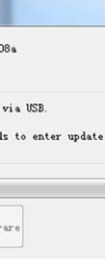
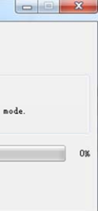

③ Use the equipped TYPE-C data cable to connect the computer USB port and game controller , Then press and hold the 3 keys HOME, X and Y of the NS009 controller at the same time for 3 seconds, until the ‘’Update Firmware‘’ color changes to black, as shown in the picture below:

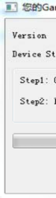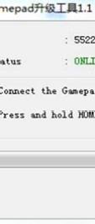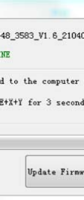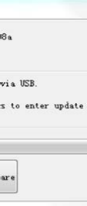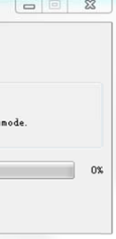

④ Click "Update Firmware" to upgrade, and wait for the upgrade to complete. It prompts "SUCCESS"100%’ green means the upgrade is successful. The controller cable can be pulled out.
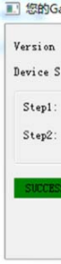
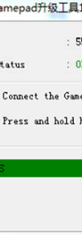
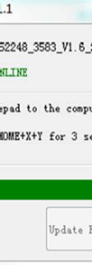
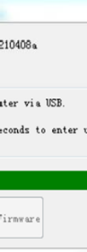
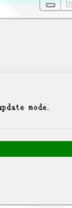
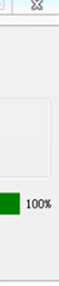
⑤ After the controller upgrade is completed, take the N-Switch console, and go to the
system settings---controllers and sensors--Disconnect controllers :

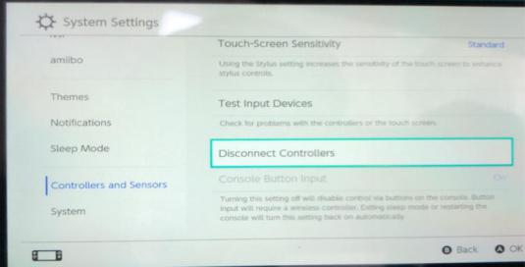

⑥ Then long time press the 'X' key N-Switch console to make clearing
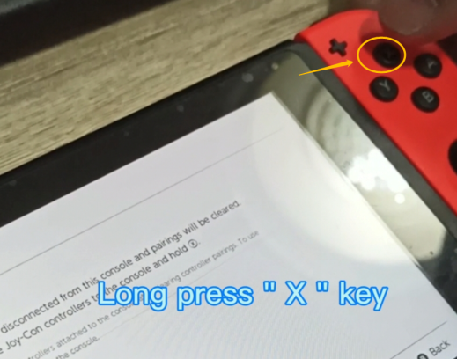

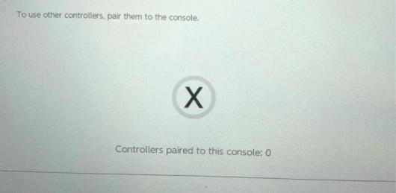
⑦ Successfully cleared
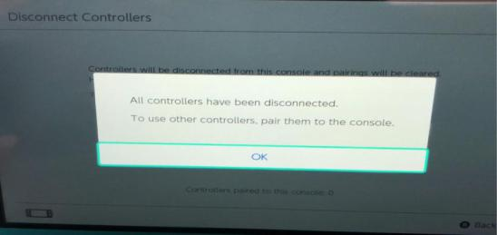

⑧ Re-start the N-Switch console, you can use the NS009 controller to pair with the N-SWITCH console again.

How to Connect N-Switch again:
- Click “Controllers” to enter “Change Grip/Order” in main interface menu of the N-Switch , and enter the controller pairing mode;
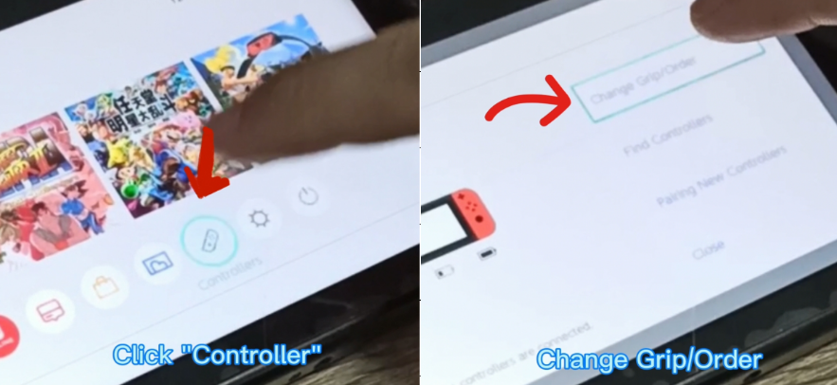
B) Press the Y and HOME key of NS009 controller at same time for 3 seconds to enter the pairing mode, the LED flashes quickly in the form of a marquee, and the controller will be automatically paired with the console. Once the connection is done, the LED light will be on corresponding !
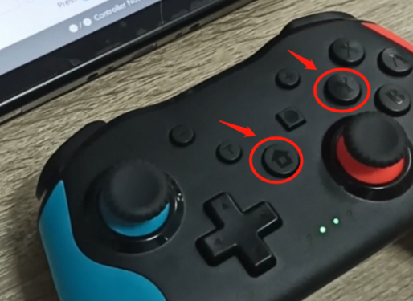
Enjoy the playing !

